## **Recommended:**

**Good Line Spacing and Word Spacing**

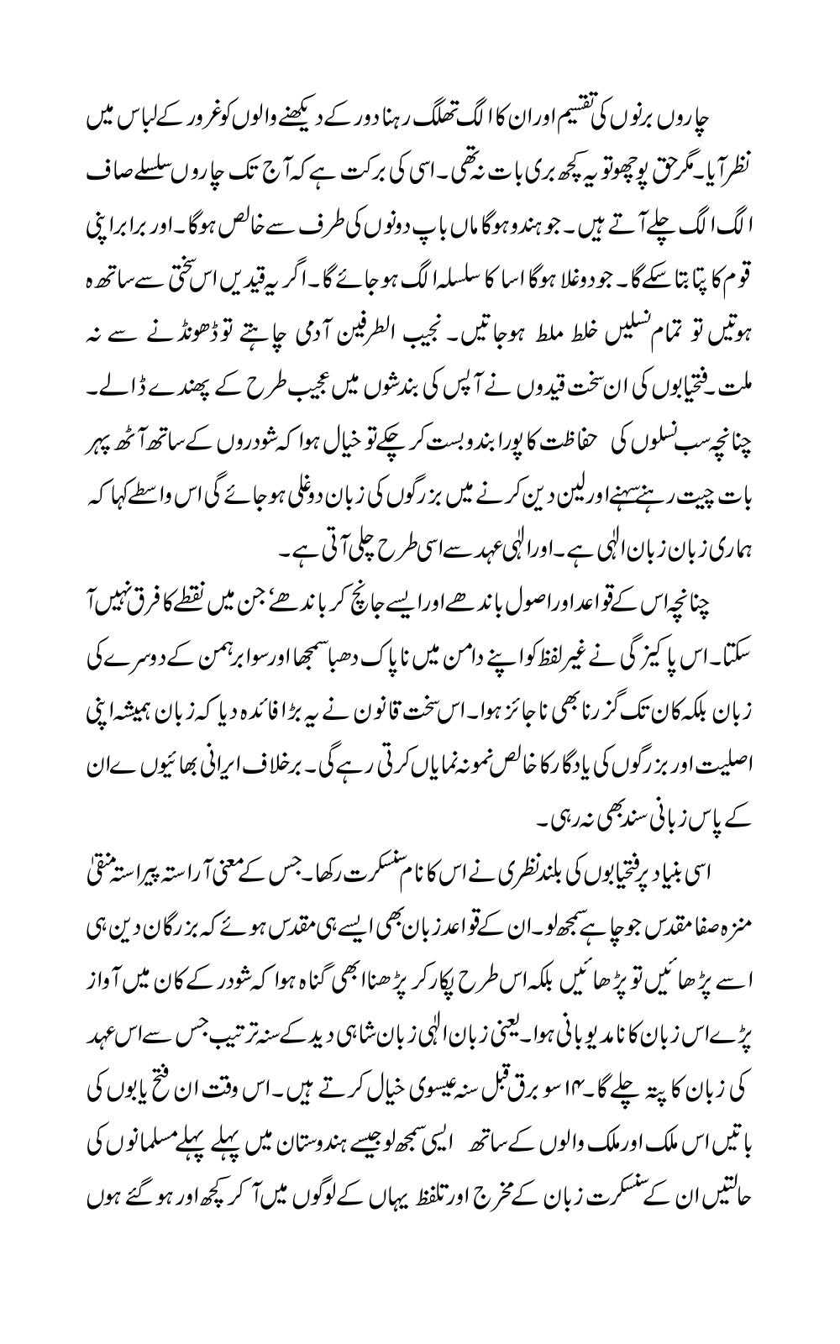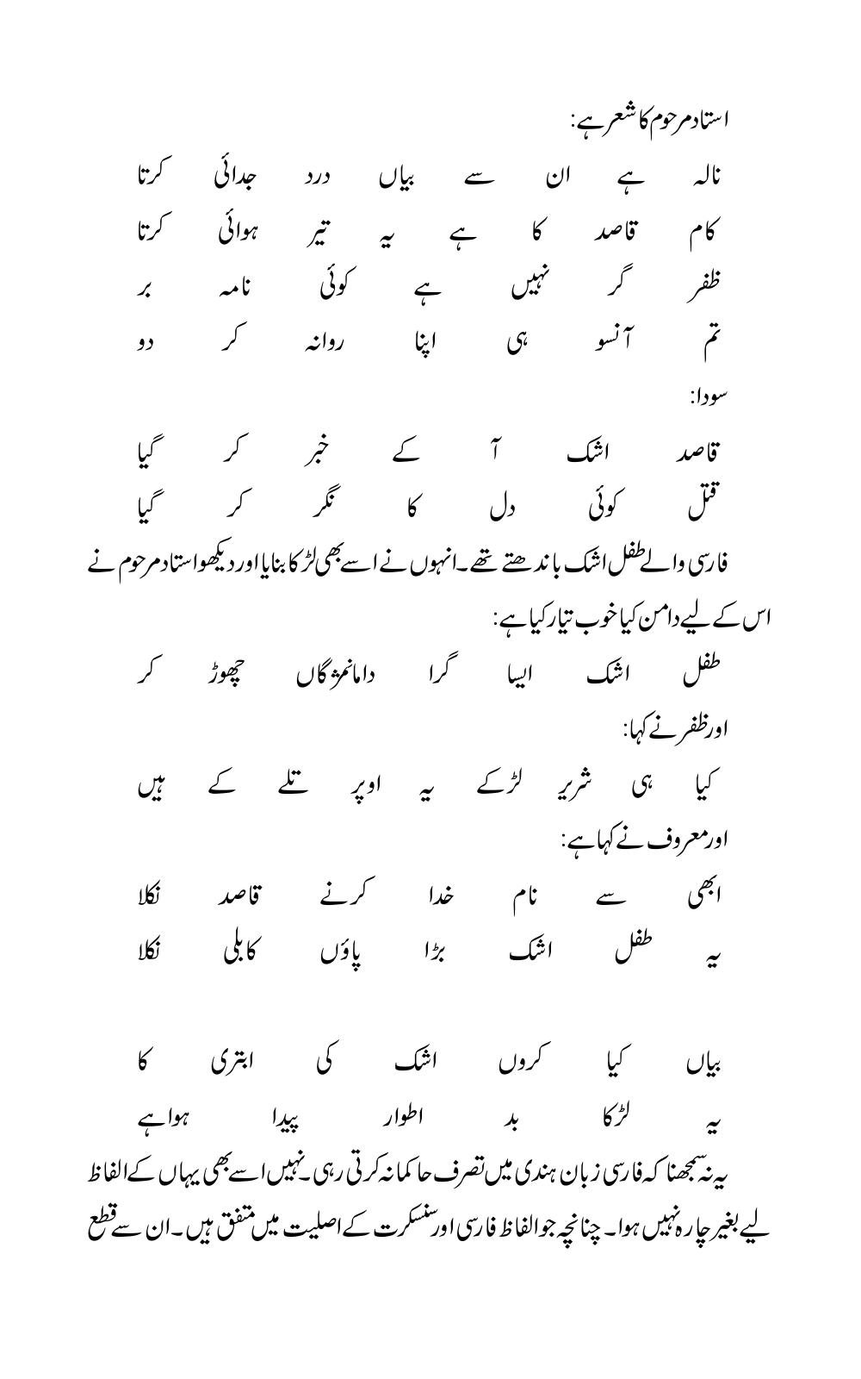

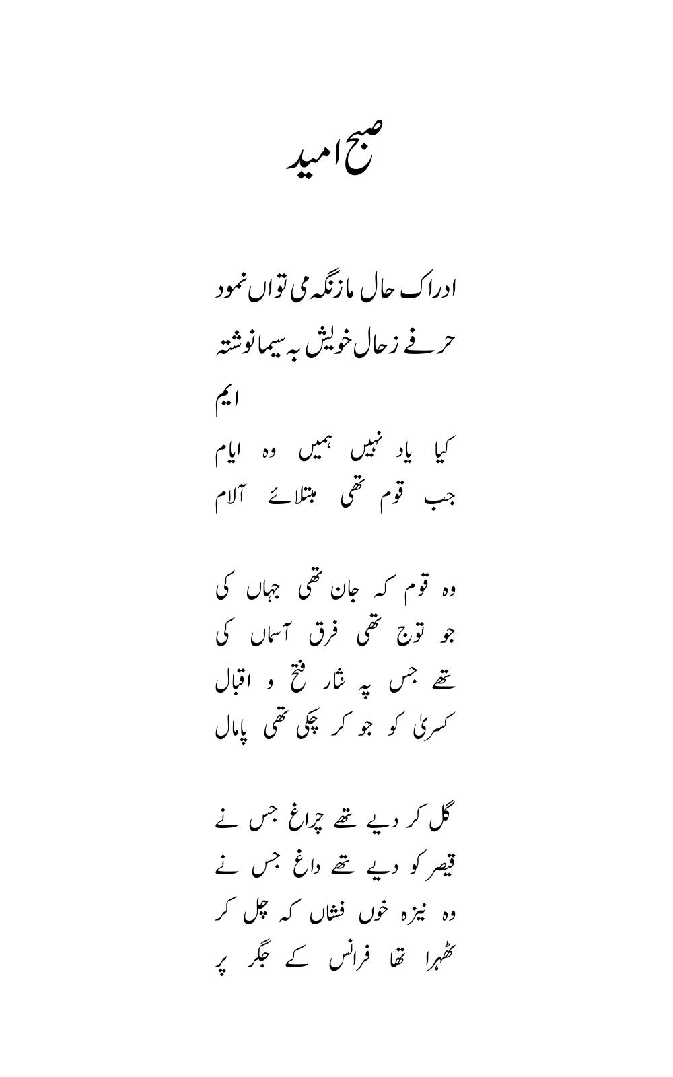

## 

## 

## **Not Recommended**

**Low Line Spacing and smudged background**

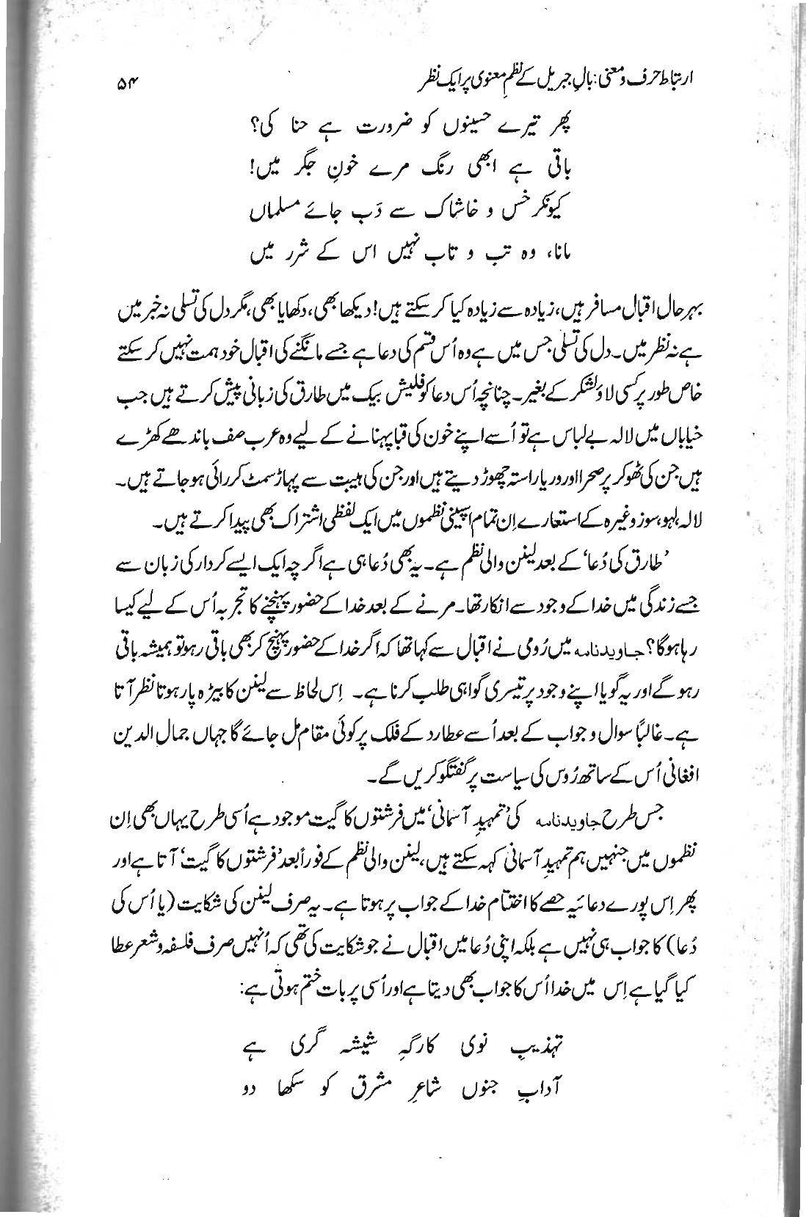

**Blurred Text with non-white background**

